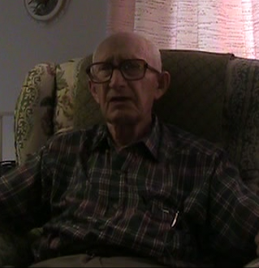

GEORGE FISHER
U.S. SOLDIER
&
FAMILY MAN

FATHER WAS A SOLDIER
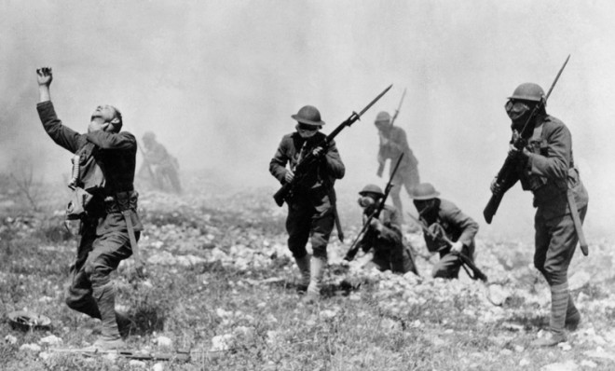
“My father was a stone Mason and he was in also a soldier in WW1, he was disabled from the gas warfare. My father was with Company L 121st infantry. When he left the service the depression was in full effect and there was no work After Roosevelt became president, my father got a job on community building projects, the depression was a tough time.”

BREAK OUT OF THE WAR
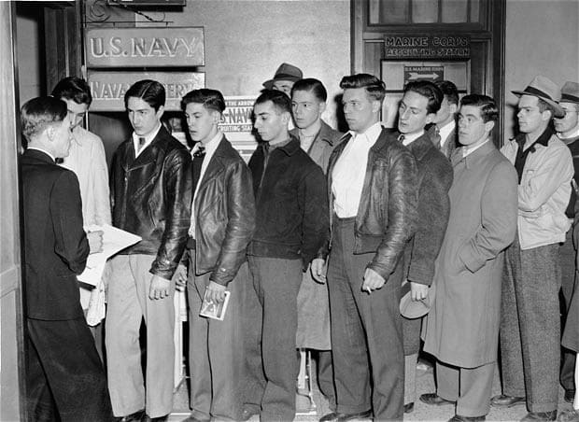
“World War 2 came around and I had a job in another hotel in Bedford, one of the musicians and I put together a band, this made me some money. I worked here for another year in a half. In 1941 I was asked to work at a hotel in Miami Florida, a 33 room hotel. This was in november and I was working at night as well. The hotel was doing very well Sunday December 7th, I was seeing a movie and I heard people talking about Pearl Harbor so I walked up the street to the hotel, I found my boss and asked him if he heard the Japanese had bombed Pearl Harbor. When I was ready to come home my half brother was already being trained my other brother was working at the Pentagon. When I got home the draft notice was there in April and May 1st 1942 I was sent to New Cumberland to get my gear I received the blessings from the townsfolk, the bus took us to get a physical this was over in two hours they put us on a train and we were shipped up to harrisburg.”

FORMING THE BAND
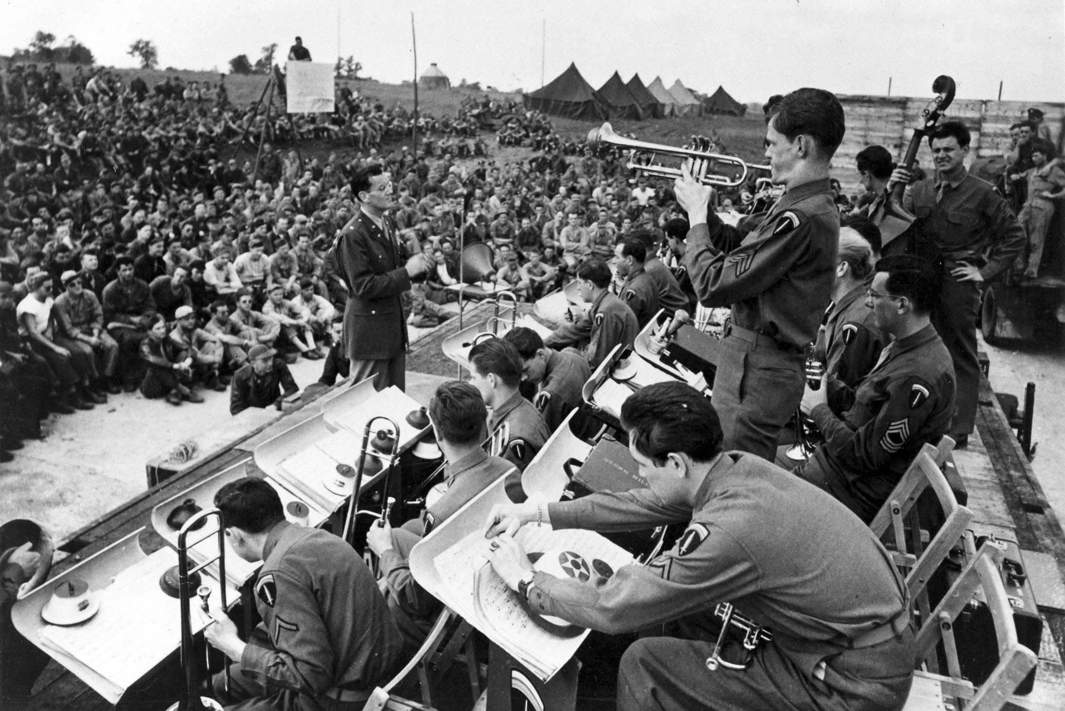
“For 3 months after basic training I went to Fort Camel in Kentucky to the 12th Armored Division which was created here. We opened this up as a new military camp, and in 3-4 weeks the base looked nice. We formed a dance band, the band would get up earlier than regulars and played music in the morning, once the replacements came in we had 50-60 musicians, we had our own barracks, We even made money playing a few events and area dances. After a year and half we did manuvers in nashville, I left the band, but on weekends we would play dances, during the week I was on manuvers.”

MIXED FEELINGS OF ARMY
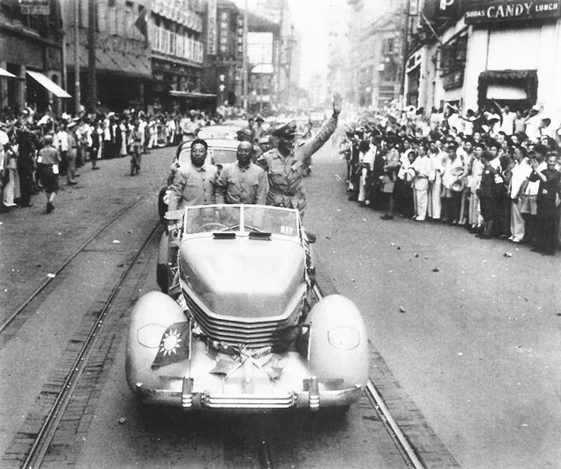
“My father got nothing from his time in the Army he would die in 1951 the same year I was married. Even with this I re enlisted after WW2. My youngest brother, David is in the military, in fact all three of my bothers are in military. My youngest brother lives in Australia and is in the military as well but he retired in 1969, then I retired in 1966.”

